## Introduction

In this project, I have developed a single page web application for the COMP1004 module. This report focuses on the project plan, which follows the software development lifecycle (SDLC) principles. By adhering to a structured approach, this project aims to efficiently manage time and resources, ensuring a successful outcome of the game within the proposed deadlines. The software development lifecycle is followed by the design document, which showcases how I have utilized sprints to design and develop the architecture for the web application.

The design document presented here outlines a game design document for Retro Golf. This nostalgic retro-golf game challenges players to compete in 9 different holes to achieve the lowest scores possible. It features a leaderboard to track users’ names, scores, and time spent playing. Each step that I have taken to complete this project is documented within this report, highlighting the issues and constraints that have had an impact on designing and developing the web application. Legal, social, and ethical concerns that arise throughout the project are also addressed.

## Software Development Lifecycle

For this project, I have implemented the scrum methodology, ensuring regular sprints take place every two weeks. Each sprint has been meticulously planned, with each task following the product backlog. This approach has allowed for a dynamic response to setbacks and new discoveries, ensuring that the project remains on track.

These are the software development life cycle steps that have been followed:

Planning

It took a week to complete the planning phase for this project. During this time, I explored various game ideas that I thought would be unique and fun for players. I thought about different genres, such as racing and shooting games, but in the end, one unique game stood out to me: Retro Golf. I had not seen any games like this and thought that it would be a good opportunity to work on this project. I took notes on how the game would work and created the project vision and background. I finished the planning stage by researching any issues that could arise.

Requirements analysis

To start this phase, I created the user stories and product backlog to plan out the priority of tasks to take place. During each sprint, the priority of tasks was discussed to decide what tasks would be focused on before the next sprint.

Design

Once everything had been planned and the requirements had been set, I started to create the designs. I created the basic user cases and class diagrams and the sitemap and wireframes to give me a solid foundation for how the game will turn out. These are eventually followed by more advanced UML diagrams, which include package and sequence diagrams. This architecture was a big help in getting a feel for how the game would actually turn out, and it made the programming much easier.

Implementation

After the architecture and designs were up-to-date, I used the basic diagrams to create the initial home page design for the game. It gave me a good starting point by laying out the different features of the game, but it had little functionality. I started to work on the functionality of the game and encountered many issues with the ball mechanic. I moved away from the plan by creating a ball-dragging mechanic, which turned out to be very successful. After many difficult weeks of trial and error, I finished all of the functionality for the game. This meant that it was time to test the game.

Testing

For the testing, I made sure that everything was working successfully, and I touched up on some little details that needed to be improved. I created a testing plan that I used, which ensured that I tested everything. I also wanted to add some bonus features to the game, so I decided to add a ball colour picker. I also wanted to add a time limit feature, but I didn’t have enough time to implement it.

Deployment and maintenance

By the end of the final sprint, everything had been completed and tested to ensure that it had successfully worked. I was very happy with the outcome of the project, which meant that it was time to get the game up and running and keep on top of it with maintenance.

## Design Document

### Project vision and Background

Retro Golf’s vision is to deliver a playable SPA web game that will give off a mini golf experience, combining aiming mechanics from games like Raft Wars to 8-ball pool. Players will find themselves on a nostalgic journey, competing in nine unique levels to get the lowest scores possible. The game will be engaging and competitive fun, with features like customizable characters and golf equipment, as well as a leaderboard to keep track of your score and minutes spent playing.

The aim of Retro Golf has emerged from a passion for nostalgic games and a desire to relive the joy of classic mini golf in the modern age. The inspiration has come from timeless games like Raft Wars to 8-ball pool. The development of Retro Golf has not only been fuelled by the love for gaming but also by the ambition to create a vibrant online community. Within this community, players will be able to connect, compete, and share their experiences.

Through my extensive research and analysis, I have discovered an expanding audience for web-based games. Furthermore, I have identified that as the gaming industry continues to develop, there are very few mini golf games that not only offer immersive gameplay mechanics but also focus on the sentimental value of retro aesthetics. With an increasing demand for engaging online games, Retro Golf aims to provide players with a nostalgic journey while introducing fresh and exciting elements into traditional mini-golf gameplay.

When gathering assets for my game, the legal, social, and ethical issues need to be addressed. This means that any assets that are gathered will need to be free to use and comply with the Copyright, Designs and Patents Act 1998. The Data Protection Act also needs to be followed in regard to storing any of the players data. All of the content that will be used needs to be suitable for children. Games that are 18+ or violent can reportedly lead to depression and other mental health issues (Tortolero, S.R. et al. 2014). I want this game to be family friendly and have a positive effect on wellbeing and mental health. Every game has to be rated to ensure that it complies with The Video Recordings Act 1984. It means that the game has to be rated using the Pegi system, ensuring that it is age appropriate (BBC Bitesize 2023). This game also needs to be accessible to as many users as possible, as it allows a larger audience to access it. The accessibility for the game is also a requirement due to the UK Equality Act of 2010.

### Sprints

Sprint 1 – 29/11/23

Tasks:

- Create Game Design Document

- Define functional requirements and create user stories for the Product backlog

- Research potential issues

No issues arose during this sprint. The meeting was successful; the game idea was finalized, and both the Game Design Document (GDD) and product backlog will be completed before the next sprint. Research on potential issues throughout the project will facilitate easier handling if they arise.

Sprint 2 – 13/12/23

Tasks:

- Develop UML diagrams

- Create initial prototype for home page

No issues were encountered. The meeting was successful, with the completion of the GDD and product backlog enabling more effective task planning to meet deadlines. Challenges were researched and documented for easier resolution. Priority was given to completing the initial prototype to showcase the game concept.

Sprint 3 – 31/1/24

Tasks:

- Develop game prototype for ball and hole collision

- Integrate level scoring onto canvas

Issue:

- Home page functionality

The meeting reviewed the basic homepage, which had been created, allowing users to access the game page. Initial UML diagrams were completed. The project progressed as planned, though challenges in creating the game may arise, necessitating preparedness to address them.

Sprint 4 – 14/2/24

Tasks:

- Improve ball movement efficiency

- Implement water and sand objects

- Establish scoring functionality

Issues:

- Difficulty implementing ball movement without a physics engine

- Non-functioning level scoring

The meeting discussed setbacks in ball movement and scoring functionality. Though imperfect, the ball could collide with the hole and reset. Plans to address these issues were reviewed for implementation in the next sprint.

Sprint 5 – 28/2/24

Tasks:

- Implement ball and obstacle collisions

- Create canvas borders

- Randomize sand and water placement

- Introduce additional challenge elements

Issues:

- Ball exiting canvas

- Ineffective collision with sand and water

- Static placement of sand and water

The meeting addressed numerous issues, proposing solutions such as a dragging mechanism for the ball, randomized obstacle spawns, and canvas barriers. Despite deviating from the plan, resolving these issues would restore project progress.

Sprint 6 – 13/3/24

Tasks:

- Implement leaderboard using JSON

- Create options page displaying controls

- Add sound effects

- Integrate exit/restart button

No issues were raised in this sprint. The meeting concluded with successful implementation of previously challenging features, with minor details remaining to be added before the next sprint.

Sprint 7 – 27/3/24

Tasks:

- Finalize details and enhancements

- Add bonus features like colour picker and time limit

- Conduct thorough testing

No issues arose during this sprint. The meeting confirmed the completion of the game, with some additional features added beyond the initial plan to enhance user experience.

Sprint 8 – 10/4/24

Tasks:

- No specific tasks planned

No issues were raised in this sprint. The meeting celebrated the successful completion of the project, attributing it to dedication and feedback from previous meetings.

### Product Backlog

### User stories and Associated Use Case Scenario

|  |  |
| --- | --- |
| Name | View Options Menu |
| Short Description | User clicks on the options button. |
| page9image35689536Precondition | The game application is launched and running. |
| Post Condition | Options menu is displayed to the user. |
| Error Situations | Player enters wrong input |
| System state in the event of an error | None |
| page9image36638272Actors | User |
| page9image36649984Triggers | User clicks on the options button. |
| Standard Process | 1. User clicks on the options button. 2. Options menu is displayed. |
| page9image36442432  Alternative Process | None |

|  |  |
| --- | --- |
| Name | Start or Quit Game |
| Short Description | User chooses to either start playing the game or quit the game. |
| page9image35689536Precondition | The game application is launched and running. |
| Post Condition | Game starts or exits based on user choice. |
| Error Situations | Player enters wrong input |
| System state in the event of an error | None |
| page9image36638272Actors | User |
| page9image36649984Triggers | User clicks on either "Start" or "Quit Game" button. |
| Standard Process | 1. User clicks on the "Start" button to begin playing the game. 2. Game starts. OR 1. User clicks on the "Quit Game" button. 2. Alert asks user to quit 3. User clicks yes and quits |
| page9image36442432  Alternative Process | None |

|  |  |
| --- | --- |
| Name | View Name, Score, and Minutes Spent Playing |
| Short Description | User views their name, score, and the amount of time spent playing the game. |
| page9image35689536Precondition | The user has completed the game and accessed the leaderboard |
| Post Condition | User's name, score, and time spent playing are displayed on the leaderboard |
| Error Situations | None |
| System state in the event of an error | None |
| page9image36638272Actors | User |
| page9image36649984Triggers | User accesses the leaderboard after finishing the game |
| Standard Process | 1. User completes the game 2. User gets sent to the leaderboard screen |
| page9image36442432  Alternative Process | 1.User accesses the leaderboard through the menu |

|  |  |
| --- | --- |
| Name | Add Name and Score to Leaderboard |
| Short Description | User adds their name and score to the leaderboard after completing a level. |
| page9image35689536Precondition | User completes game and enters name |
| Post Condition | User's name and score are added to the leaderboard. |
| Error Situations | None |
| System state in the event of an error | None |
| page9image36638272Actors | User |
| page9image36649984Triggers | User completes the game |
| Standard Process | 1. User completes the game. 2. User is prompted to enter their name. 3. User submits their name. 4. Name and score are added to the leaderboard. |
| page9image36442432Alternative Process | 1.User accesses the leaderboard through the menu |

|  |  |
| --- | --- |
| Name | View Level and Total Score |
| Short Description | User views the current level and total score. |
| page9image35689536Precondition | User is playing the game. |
| Post Condition | User's current level and total score are displayed. |
| Error Situations | None |
| System state in the event of an error | None |
| page9image36638272Actors | User |
| page9image36649984Triggers | User is playing the game. |
| Standard Process | 1. User completes a level 2. Score for the previous level is added to the top of the screen |
| page9image36442432Alternative Process | None |

|  |  |
| --- | --- |
| Name | Customize the Ball |
| Short Description | User customizes the appearance of the game ball. |
| page9image35689536Precondition | User accesses the options |
| Post Condition | Ball appearance is customized according to user preferences. |
| Error Situations | None |
| System state in the event of an error | None |
| page9image36638272Actors | User |
| page9image36649984Triggers | User changes the ball colour and presses save |
| Standard Process | 1. User navigates to the customization menu. 2. User selects colour of ball 3. User clicks save 4. The ball colour is now changed |
| page9image36442432Alternative Process |  |

|  |  |
| --- | --- |
| Name | Collide with Objects |
| Short Description | User's ball collides with objects within the game environment. |
| page9image35689536Precondition | User is playing the game. |
| Post Condition | Game reacts to the collision event. |
| Error Situations | None |
| System state in the event of an error | None |
| page9image36638272Actors | User |
| page9image36649984Triggers | User's ball collides with objects in the game environment. |
| Standard Process | 1. User hits the ball into one of the objects 2. The game reacts to the collision depending on what object is hit |
| page9image36442432Alternative Process | None |

### Architecture

Package Diagram

Class Diagram

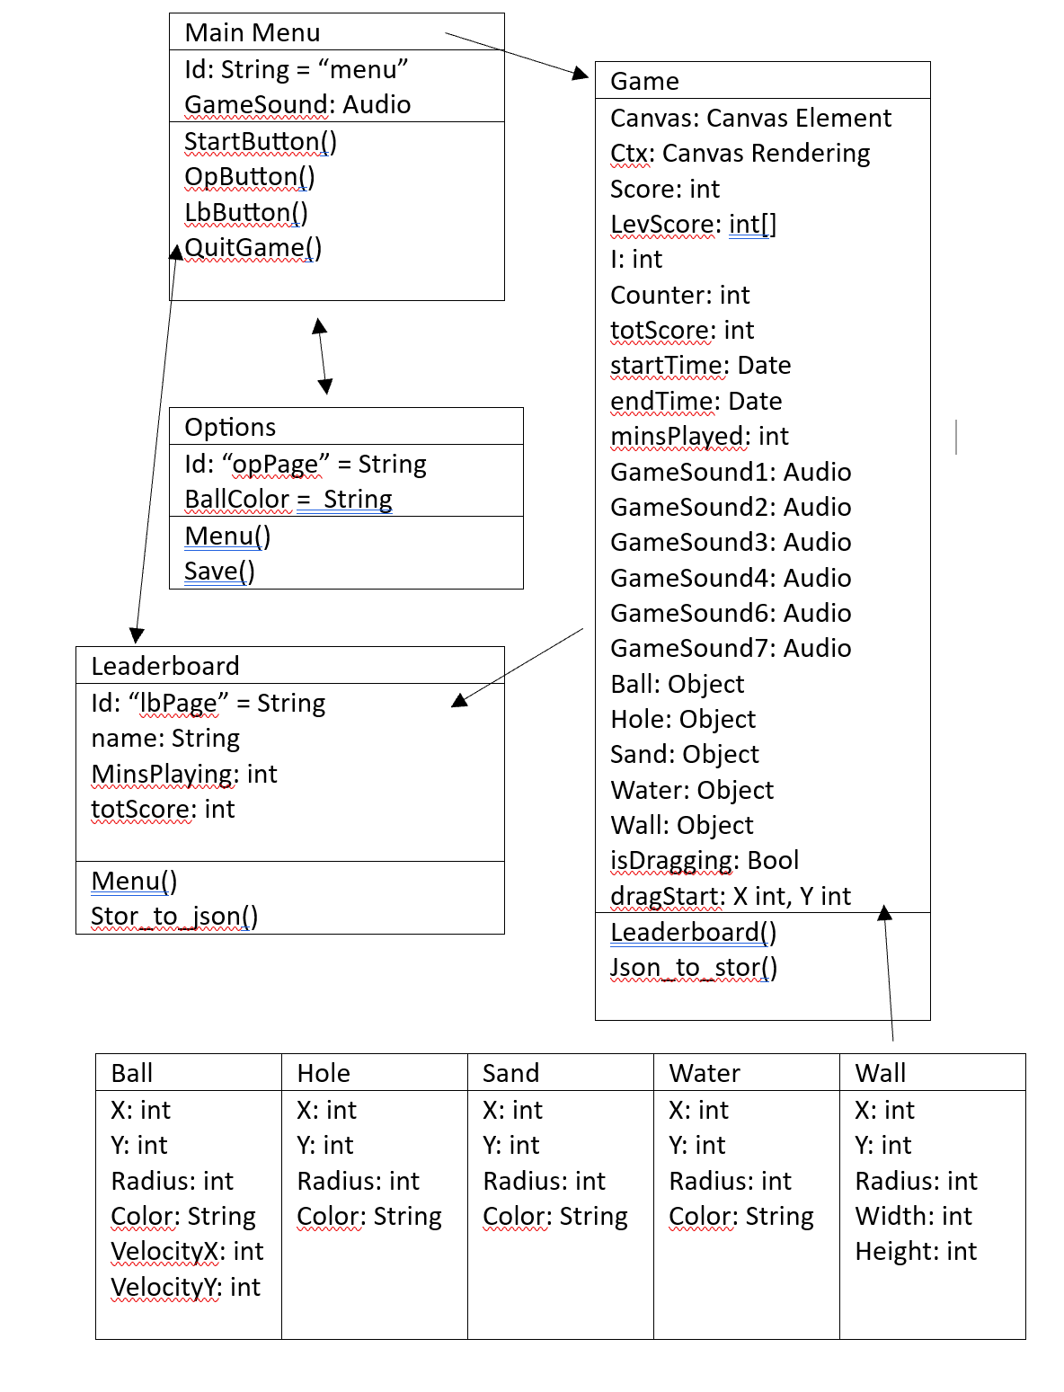

Sequence Diagram

### Sitemap

### Wireframes

### Testing

|  |  |  |  |  |
| --- | --- | --- | --- | --- |
| Test Type | Description | Expected | Actual | Status |
| Functional | Menu buttons load correct page | Game, options, or leaderboard should open when the specific button is pressed | As expected | Pass |
| Functional | Ball moves according to mouse drag | Ball should move in the direction of the users drag | As expected | Pass |
| Functional | Ball collides with hole and obstacles | Ball should have an effect when colliding with the hole or obstacles | As expected | Pass |
| Functional | Game ends when ball reaches hole in final level | The game should end and ask user to enter name once ball has reached hole in final level | As expected | Pass |
| Functional | Test functionality of sound effects during gameplay | Sound effects should function correctly after different events (level completion etc) | As expected | Pass |
| Functional | Test behaviour of ball at canvas border | Ball behaves correctly | As expected | Pass |
| Usability | Check Game interface elements are display correctly | Game buttons, input fields and canvas are displayed properly | As expected | Pass |
| Usability | Sound effects triggered by user interaction | Sounds play after ball interaction | As expected | Pass |
| Usability | Leaderboard should display with name, score, and time spent playing | Leaderboard should display accurately | As expected | Pass |
| Usability | Feedback from users on interface and controls | Users find interface intuitive and controls easy to use | As expected | Pass |
| Performance | Check game performance on different devices and screen size | Game functions correctly on various devices and screen sizes | As expected | Pass |
| Accessibility | Interface elements should have appropriate labels | Interface elements are labelled correctly | As expected | Pass |

### Noted issues and constraints

Even with the successful outcome of the project, there were still many obstacles faced throughout. I had researched some of the issues that could arise at the start of the project, which helped make overcoming them easier when they did appear.

The sprints and the kanban board helped me outline any issues that had appeared and visually showed me what I needed to prioritise first to get tasks completed before the deadline. I had many issues with the functionality of the game not working correctly, and I had to figure out different ways of implementing the different features that I wanted to include. This means that my finished game does not fully match the designs that I had created before I started to make the game because I had to find different ways of implementing things. The main issue that set me back was the ball shooting mechanic. This was completely different from what I had imagined at the start of the project, but I had expected it to cause an issue due to my research beforehand. There were many other issues as well, and the best way that I found to overcome them was through trial and error. I had to put more effort into figuring out problems and spent a lot of time trialing different methods until I got an outcome that I was happy with. This has ultimately shown me that not everything will stick to the plan, but being prepared for that to happen will result in success.

In addition to the technical challenges encountered during the development of the game, there were also legal, social, and ethical considerations that needed to be addressed.

From a legal perspective, I ensured that I complied with the Copyright, Designs, and Patents Act 1988. To ensure this, all the graphics, music, and other assets used in the game were properly licenced to avoid any potential copyright and legal issues. Furthermore, I had to pay attention to the Data Protection Act 2018, which is used to safeguard any personal information that I collected through the game (such as the leaderboard name).

When considering the social issues, I had to carefully decide on the games content and themes to ensure that they were appropriate for all of the players. This meant that I needed to avoid any content that could be perceived as discriminatory or offensive. Additionally, I had made the writing as big as possible and added a customizable feature on the ball colour to consider people with visual impairments.

For the ethical issues, I had to ensure that I provided honesty to the users of the game. This means making any in-game purchases, advertising, or data collection clear to the users; however, I had not included any of this within the game. Moreover, the game does not include any violence and is family friendly for anyone to be able to play.

### Poster

### Github repo link

<https://github.com/Mattrfish/Comp-1004---Computing-Practice.git>

### References

Game Assets

Sand Step by kvgarlic (pixabay)

* Source: https://pixabay.com/sound-effects/sand-step-87182/

Splash by blaukreuz (pixabay)

* Source: <https://pixabay.com/sound-effects/splash-by-blaukreuz-6261/>

Golf Club hitting bed by Gareth_H (Freesound)

* Source: <https://freesound.org/people/Gareth_H/sounds/365790/>

Hard Golf Ball Hit by Jellytots_julie (Freesound)

* Source: <https://freesound.org/people/Jellytots_Julie/sounds/654550/>

Golf 8 by zolopher (Freesound)

* Source: <https://freesound.org/people/zolopher/sounds/75217/>

Bluethroad bird industrial area by klankbeeld (Freesound)

* Source: <https://freesound.org/people/klankbeeld/sounds/667433/>

Success Fanfare Trumpets by Unknown Artist (pixabay)

* Source: <https://pixabay.com/sound-effects/success-fanfare-trumpets-6185/>

Bliss by Luke Bergs

* Source: <https://soundcloud.com/bergscloud/bliss>
* License: Creative Commons Attribution-ShareAlike 3.0 Unported (CC BY-SA 3.0)
* License URL: <https://creativecommons.org/licenses/by-sa/3.0/>
* Promoted by Chosic: <https://www.chosic.com/free-music/all/>

Image by Freepik

* Source: <https://www.freepik.com/free-vector/golf-course-background-flat-style_1919426.htm#query=golf%20background&position=41&from_view=keyword&track=ais&uuid=f2dc8c45-f52d-4586-a55e-5add2ed5af16>

Web sites

Copyright, designs and patents act 1988 (1988) Legislation.gov.uk. Available at: https://www.legislation.gov.uk/ukpga/1988/48/contents (Accessed: 12 April 2024).

Data protection act 2018 (2018) Legislation.gov.uk. Available at: https://www.legislation.gov.uk/ukpga/2018/12/contents/enacted (Accessed: 12 April 2024).

Equality act 2010 (no date) Legislation.gov.uk. Available at: https://www.legislation.gov.uk/ukpga/2010/15/contents (Accessed: 15 April 2024).

Regulation - Computer and Video Games - GCSE Media Studies Revision - BBC Bitesize (2023) BBC News. Available at: https://www.bbc.co.uk/bitesize/guides/z2g7p39/revision/3#:~:text=Video%20game%20ratings%20are%20mandatory,below%20the%20respective%20age%20bar. (Accessed: 15 April 2024).

Tortolero, S.R. et al. (2014) Daily violent video game playing and depression in preadolescent youth, Cyberpsychology, behavior and social networking. Available at: https://www.ncbi.nlm.nih.gov/pmc/articles/PMC4227415/#:~:text=Overall%2C%20students%20who%20reported%20playing,(Cohen’s%20d%3D0.16). (Accessed: 15 April 2024).

Video recordings act 1984 (1984) Legislation.gov.uk. Available at: https://www.legislation.gov.uk/ukpga/1984/39/section/2A (Accessed: 15 April 2024).